Station 1: Organization
Directions: Complete the following steps to improve the organization of this student’s essay.

- Sort the sentences to create organized sections.
- Which sentences did you put together? What order are they in?
- Describe WHY you created those sections and how the sentences fit together.

Station 2: Voice
Directions: Write a message (think text/email/note) that fits each audience and situation. Then answer the reflection question.
- Audience: Your mom or dad
Situation: You want to go to a movie on a school night.
- Audience: Your girl/boyfriend.
Situation: You want to go to a movie on a school night.
- Audience: Your teacher
Situation: You forgot to do your homework.
- Audience: Your best friend
Situation: You forgot to do your homework.
- Audience: Your boss
Situation: You have the stomach flu.
- Audience: Your best friend.
Situation: You have the stomach flu.
Reflection Question:
- How does the audience change how you wrote the message?
Station 3: Sentence Fluency
PART 1 Directions: Read the following passage. Then answer the discussion questions.
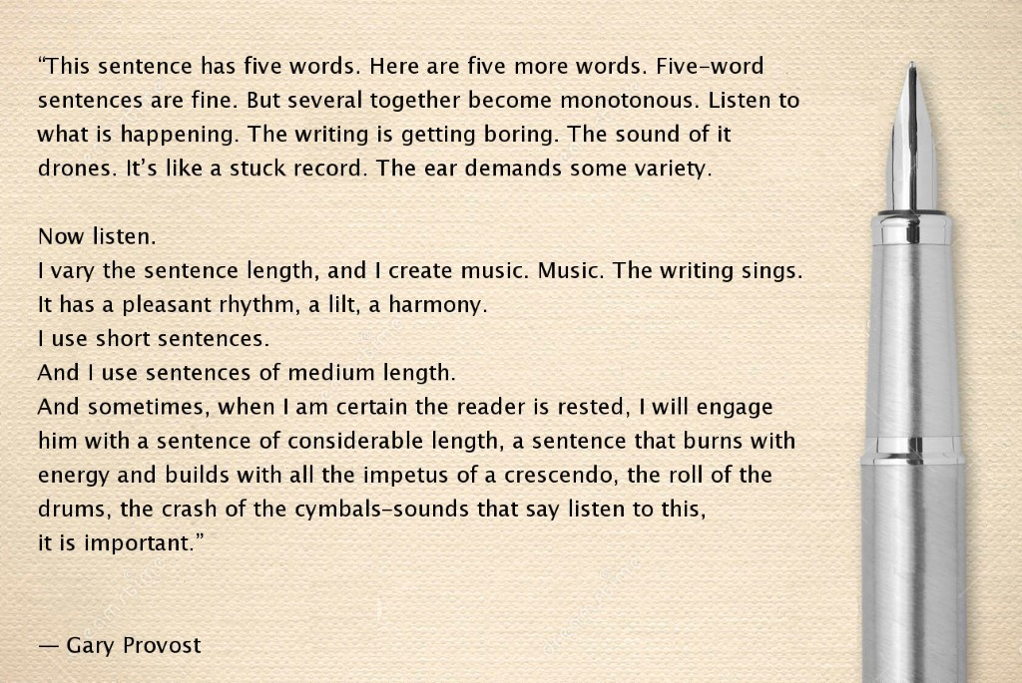
- How does the author change the rhythm of the poem?
- Does fluency matter? Why or why not?
PART 2 Directions: Read the following paragraph. Then change the sentences to improve the fluency.
I like Justin Timberlake. Justin Timberlake is cute. Justin Timberlake is talented. He sings songs. Sometimes he is on Saturday Night Live. Sometimes he is on Saturday Night Live with Jimmy Fallon. He is friends with Jimmy Fallon.
Station 4: Conventions
Directions: Identify the correct form of the word in each sentence.
- I couldn’t decide ( which / witch ) color shoes I wanted.
- If a cat falls ( of / off ) the counter, it will land on ( its / it’s) feet.
- Make sure you do ( your / you’re ) homework right after school.
- I talked ( to / too / two ) my brother yesterday.
- ( Are / our ) you going to be on ( are / our ) baseball team?
- He bought ( to / too / two ) speakers ( to / too / two ) complete his surround-sound system.
- I saw ( their / there / they’re ) mom sitting ( their / there / they’re ).
- I think ( their / there / they’re ) in trouble.
- The dog chewed on ( its / it’s ) squeaky toy.
- She couldn’t remember ( were / where ) she had put her purse.
- I would rather be poor and happy ( than / then ) rich and sad.
- I ( hear / here ) that you won tickets to the Beyoncé concert.
- If the ( weather / whether ) is bad, we will have to cancel our camping trip.
Station 5: Conventions
PART 1 Directions: Read the following celebrity tweets. Then fix the tweets so they have correct grammar, spelling, and punctuation.
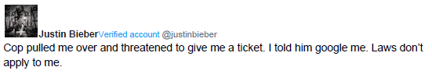
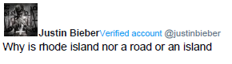
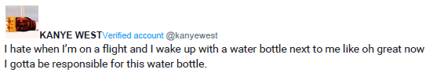
PART 2 Directions: Answer the following questions.
- Does it matter if celebrities use correct conventions? Why or why not?
- When it is “ok” to not use proper English conventions? List at least 5 situations.

